Image Transforms and Facial Eigen-Images

*Mikhail Podvalkov*

*Due to March 22, 2022*

1. **Introduction**

The purpose of computer assignments is to solve the problem of reducing data images without losing the information about facial patterns and creating methods of classification of these patterns in the image—the small Yale face database used to accomplish this goal. The image Yale face database was centralized in the middle of the face to create similar images to achieve better pattern recognition using MATLAB code "Center_Face.m". The computer assignments created a PCA model of the same subcategory of images in MATLAB code [1]. The method used Eigen images finding in the model to find reconstructing images in the training dataset and out this set and find the error of the method. Furthermore, a classification test was created on this dataset using PC's method and the Eigen images. Moreover, the test dataset was increased to 2/3 of the small Yale face database and tested the rest data method and utterly new with finding the SNR.

1. **Theory**

The algorithm for extracting Eigen images [2] has several steps. The first step was to find the mean-subtract images of all data sets. The image inset was transformed into a vector, and fined sample mean image (1) and used to crated a mean-subtract (2). So the final data matrix was looked like in equation (3).

$$\underline{μ}=\frac{1}{M} \sum_{i=1}^{M}{\underline{x_{i}}}\left(1\right)$$

$$\underline{\overline{x_{i}}}=\underline{x_{i}}-\underline{μ} \left(2\right)$$

$$Υ=\frac{1}{\sqrt{M}}\left[\begin{matrix}\underline{\overline{x_{1}}} & … & \underline{\overline{x_{M}}}\end{matrix}\right](3)$$

The second step was to find the minor version of the covariance matrix (4) and find the eigenvectors and eigenvalues (5).

$$R^{'}=Υ^{t}Υ (4)$$

$$R^{'}{\underline{ζ}}_{k}=γ_{k}{\underline{ζ}}_{k} (5)$$

The third step was to find Eigen images by finding the eigenvector related to the largest eigenvalues (7). The number of eigenvalues was found by using inequality (6) [3] where $γ_{k}$ It is sorted in descending order.

$$\frac{\sum_{i=1}^{P}{γ_{i}}}{\sum_{i=1}^{M}{γ_{i}}}<0.9 P≤M \left(6\right)$$

$$\underline{ξ_{k}}=Υ{\underline{ζ}}_{k} (7)$$

The last step was to find the reconstructed image (8).

$$\hat{\underline{x_{i}}}=\sum_{k=1}^{P}{\frac{{\underline{ξ_{k}}}^{t}\underline{\overline{x_{i}}}\underline{ξ_{k}}}{γ_{k}}}+\underline{μ} (8)$$

The classification was created by finding opposite subcategories, "sad" and "happy." The two images center the subcategories "sad" and "happy," and the test images were reconstructed into the two subcategories PCs. After that the images was reconstruct with their respective subcategory eigen-images and eigenvalues. This subset of data was used to find the center of the category by using mean function of the image. After that, the minima distance (9) of these two pairs corresponds to the image class.

$$C=min{\left\|Y-X\right\|}_{2}$$

1. **Results and discussion**

The Matlab code provides an algorithm for extracting Eigen images and reconstructing them. The method was tested on the subcategory of "happy" and reconstructed of the most dominant PCs flinging by (6). (Fig 1)

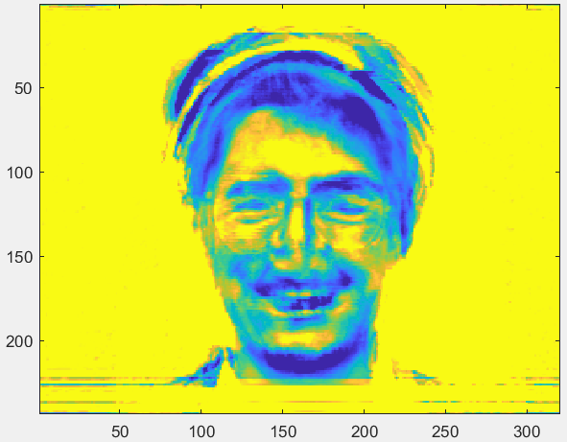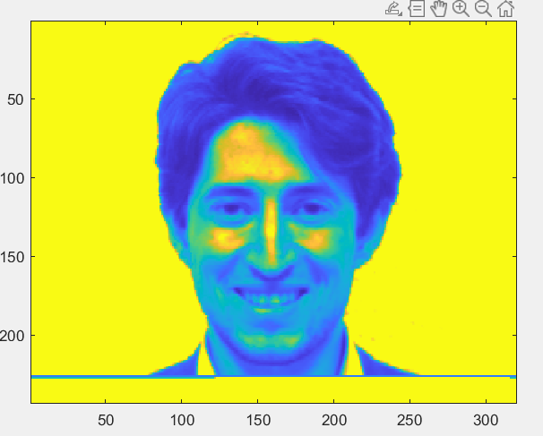

*Figure 1 The reconstruct and the original image*

The reconstructed image saves the facial pattern like "smile," "eyes," "nose," etc. However, we can see in fig.1 that it reduct the other part of the images, which is not the same in the dataset. The SNR of the two images is equal to 0.4054, which is relatively small.

After that, reconstruction was checked on the four images that were not in the data set (Fig 2).

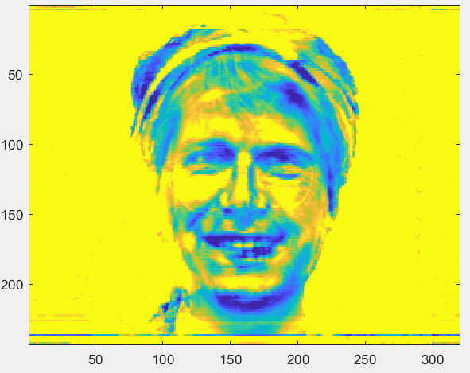 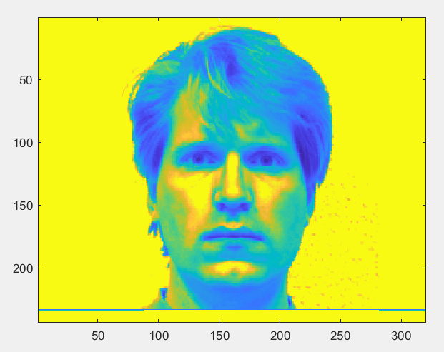

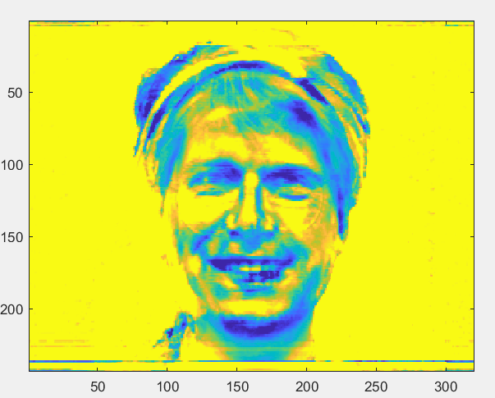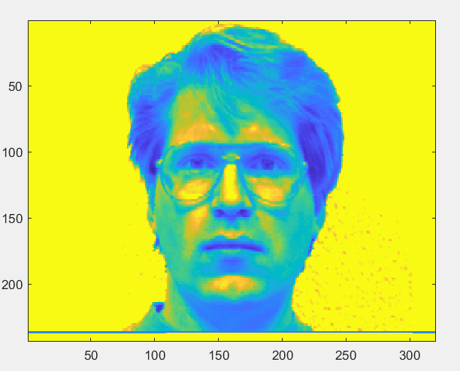

*Figure 2 The reconstruct and the original image, which is not included in the dataset*

The reconstructed image is saved the facial pattern of the original image (we can see the glasses on the images). However, it puts the most dominant pattern of the training set, "happy," on the reconstructed image. Also, the number of images in the training set is not enough to accept the image. The SNR of the four images is 4.9302, which is much bigger than the SNR of the image in the train set.

The next part of the computer assignments was to increase the number of the training set on 2/3 of all small Yale face databases. Moreover, they tested the rest of the data using SNR. Moreover, the final model was tested on the image, which is not included in the database (Fig. 3).

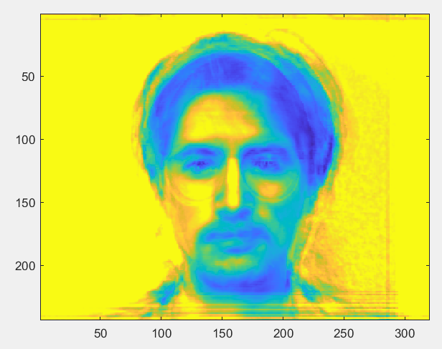 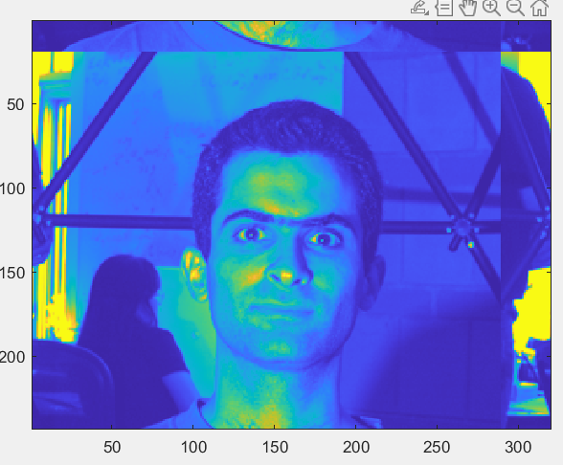

*Figure 3 The reconstruct and the original image, which is not included in the dataset*

The reconstructed image saves the facial pattern of the original image, such as eyes, lips, chin, etc. However, the background of the new images did not meet in the training set, and this information was lost, which is maybe a way of reducing the image. The test dataset's average SNR equals 1.1561, which is less than in the previous part. Thereby to this, it can be concluded that the accuracy is increased.

The classification was built by using the above method. The result is shown in figure 4.

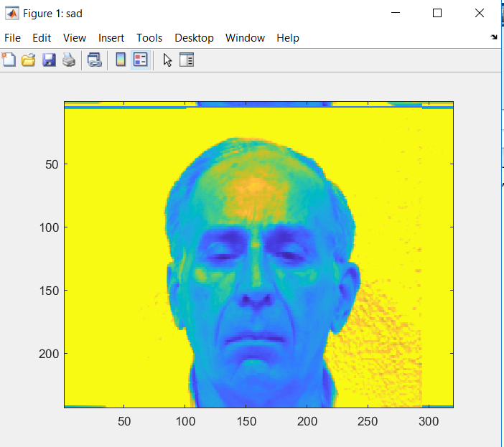

*Figure 4 The result of the classification image.*

1. **Conclusion.**

The computer assignments show how to reduce the image without losing critical information. Also, the computer assignments show a method to find the facial patterns of the images and use it to create the classificatory. The way to improve it is to use more simile data to increase the accrue of the method and increase the number of the category of this data. Another way to improve it is to do pre-method processing of the image, such as quantization. Moreover, this method could be used on transformed images which could reduce complexity and increase its accuracy of it.

Reference

1. The official MATLAB site: <https://www.mathworks.com/>
2. The professor M.R Azimi lecture 13-14 page 8-11
3. The Yifan Yang office hours